SVCR GOVERNMENT DEGREE COLLEGE, PALAMANER

INTERNAL QUALITY ASSURANCE CELL

2021-22
MINUTES
03.03.2022
The members of Internal Quality Assurance Cell met in the Principal’s chamber on 03.03.2022 at 4.30 PM to discuss and resolve the following issues.
- It is resolved to send a letter of approval to the CCE for the sanction of amount to meet with the expenses of NAAC assessment.
- The members of IQAC have gone through the QnMs and QlMs prepared for NAAC SSR.
- The observations have been noted down and the same will be incorporated in the document.
- It is resolved to motivate the staff and the students for the NAAC visit in the college.

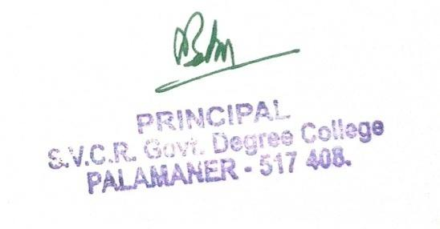

SVCR GOVERNMENT DEGREE COLLEGE, PALAMANER

INTERNAL QUALITY ASSURANCE CELL

2021-22
MINUTES
31.07.2021
The members of Internal Quality Assurance Cell met in the Principal’s chamber on 31.07.2022 at 4.30 PM to discuss and resolve the following issues.
- It is resolved to submit the IIQA.
- It is resolved to complete the records for the Academic Audit.
- It is resolved to conduct one internal for the UG students.
- It is resolved to conduct remedial coaching for the students.

